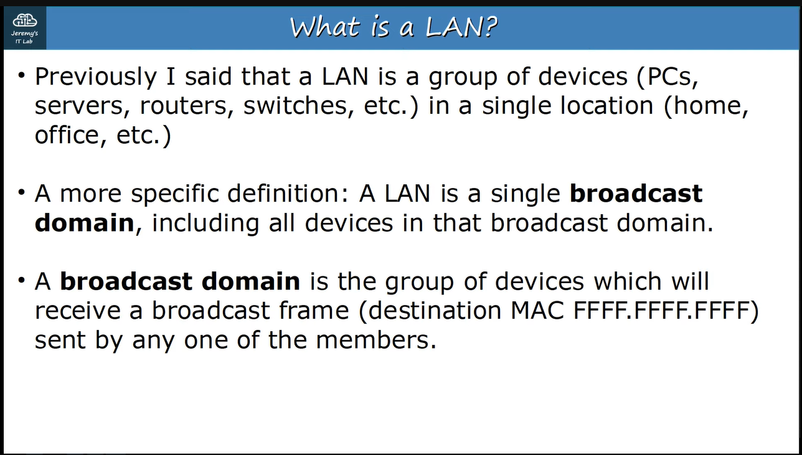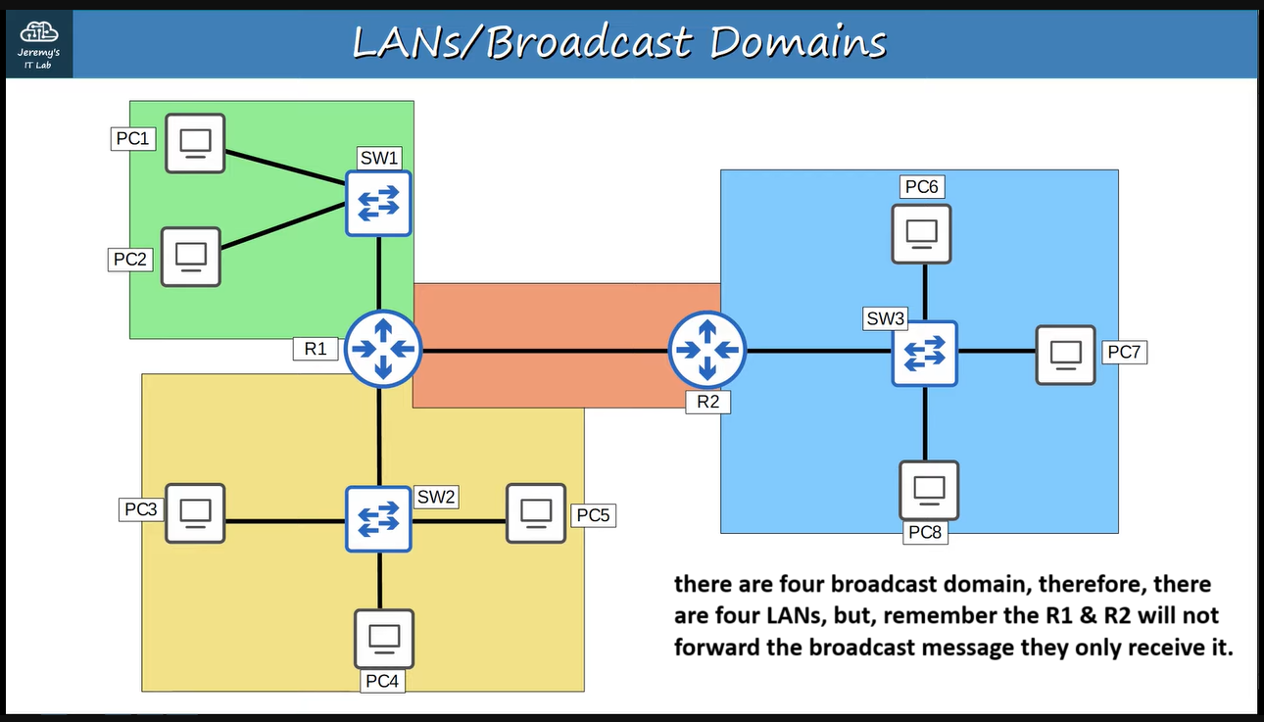

**Suppose that there are three departments Engineering, Sales and HR in a company in a LAN, therefore, when a PC of a department sends a broadcast message then PCs of all departments will receive and this can be a problem for both security and network performance ↓**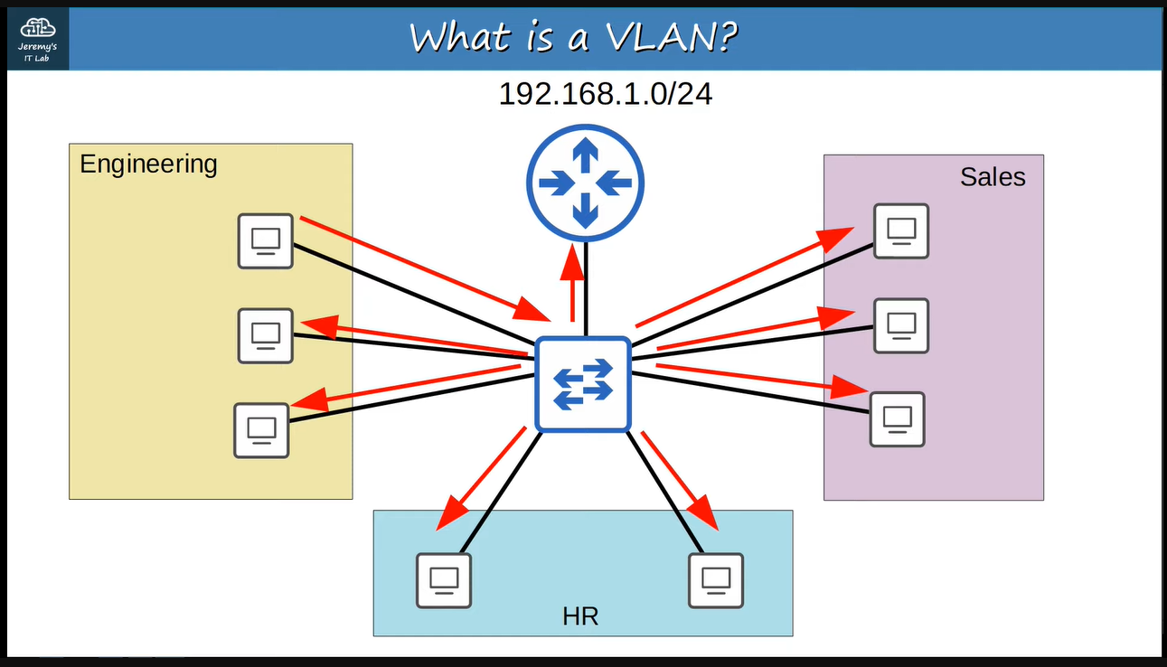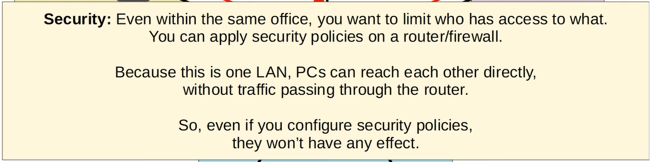

**So, let’s split up these departments into separate subnets ↓**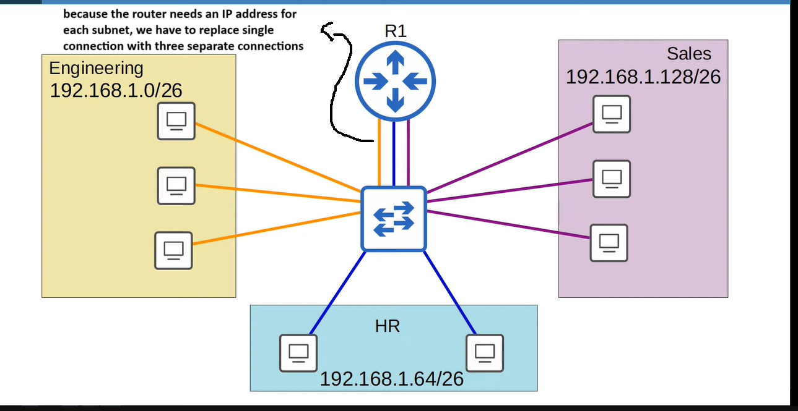

**If PC1 sends the frames to PC2 then it will send it to R1 and R1 will send it to PC2 ↓**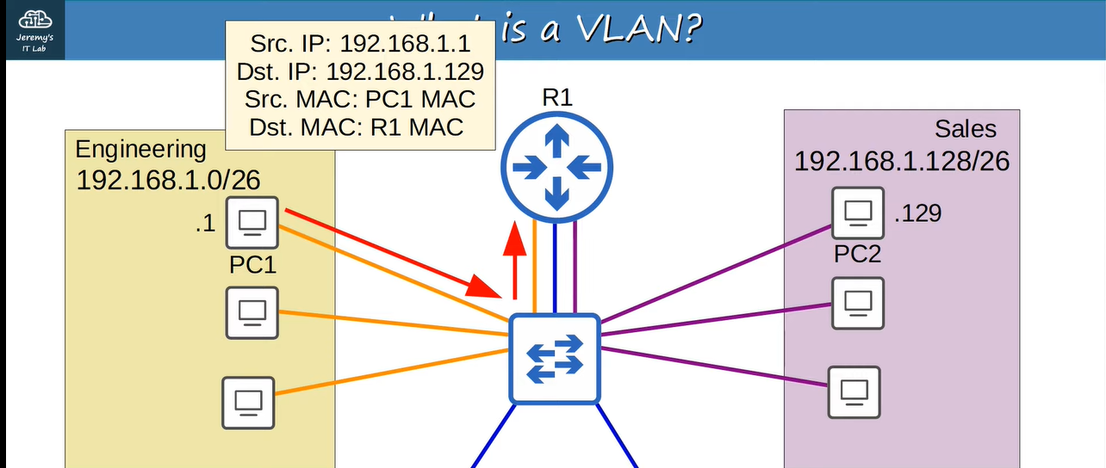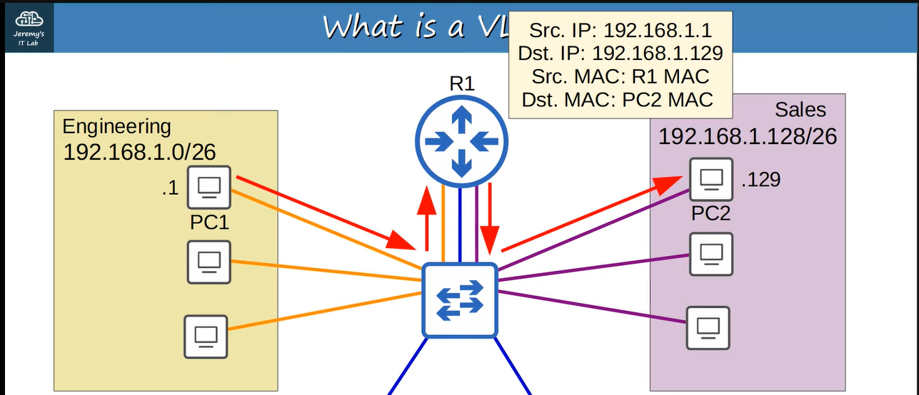

**But still now, if PC1 sends the broadcast message then switch will flood it to all and this is the problem as we mentioned above. Although we separated the three departments into three subnets but they are still in the same broadcast domain ↓**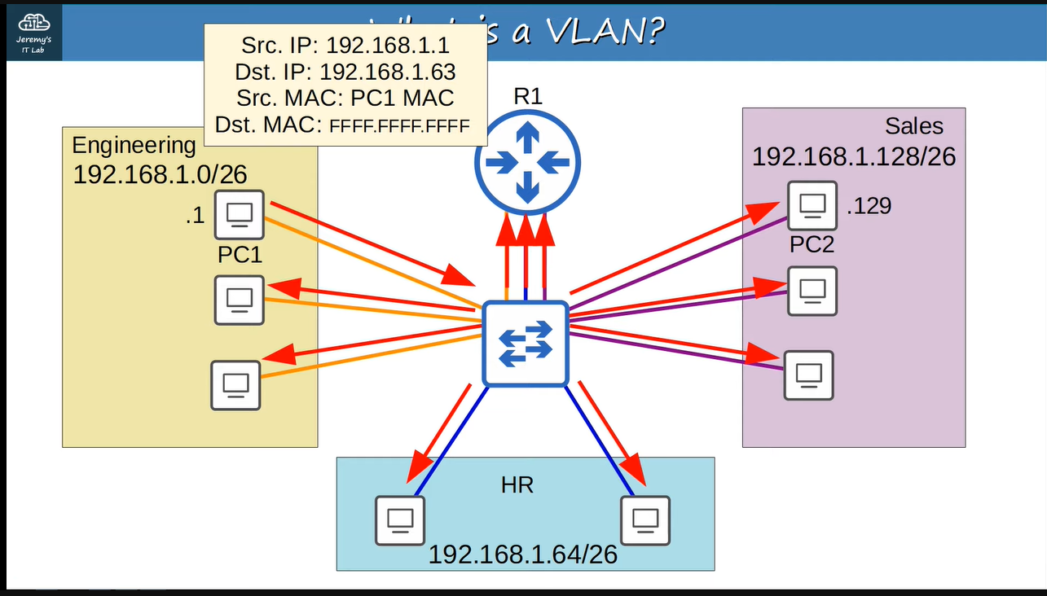

**This is where VLANs come in, we can separate these three departments at layer 2 using VLANs. Now we will assign them different VLANs ↓**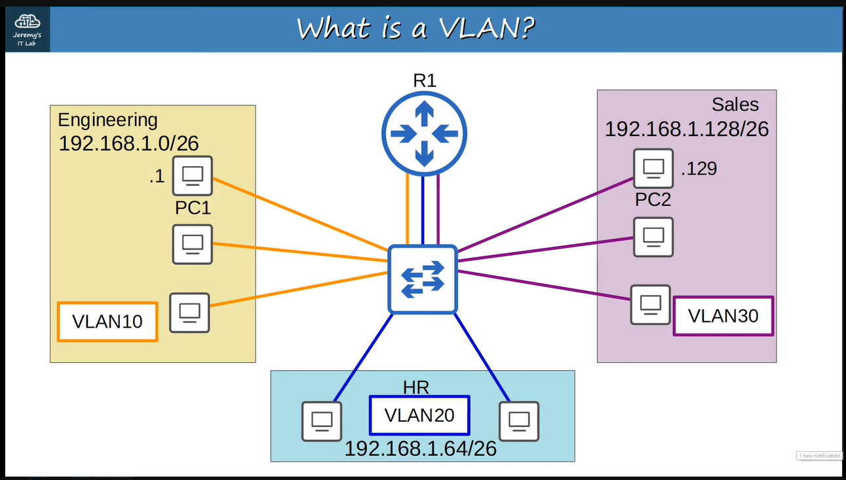

**To assign the VLANs, we configure the switch interface to be in a specific VLAN and then the end host connected to that interface is the part of that VLAN. Switch considers each VLAN as a separate LAN and not forward traffic between VLANs including broadcast or unknown unicast traffic.**

**After configuring the VLANs, if PC1 sends broadcast frame then the switch will flood it to the VLAN10 only ↓**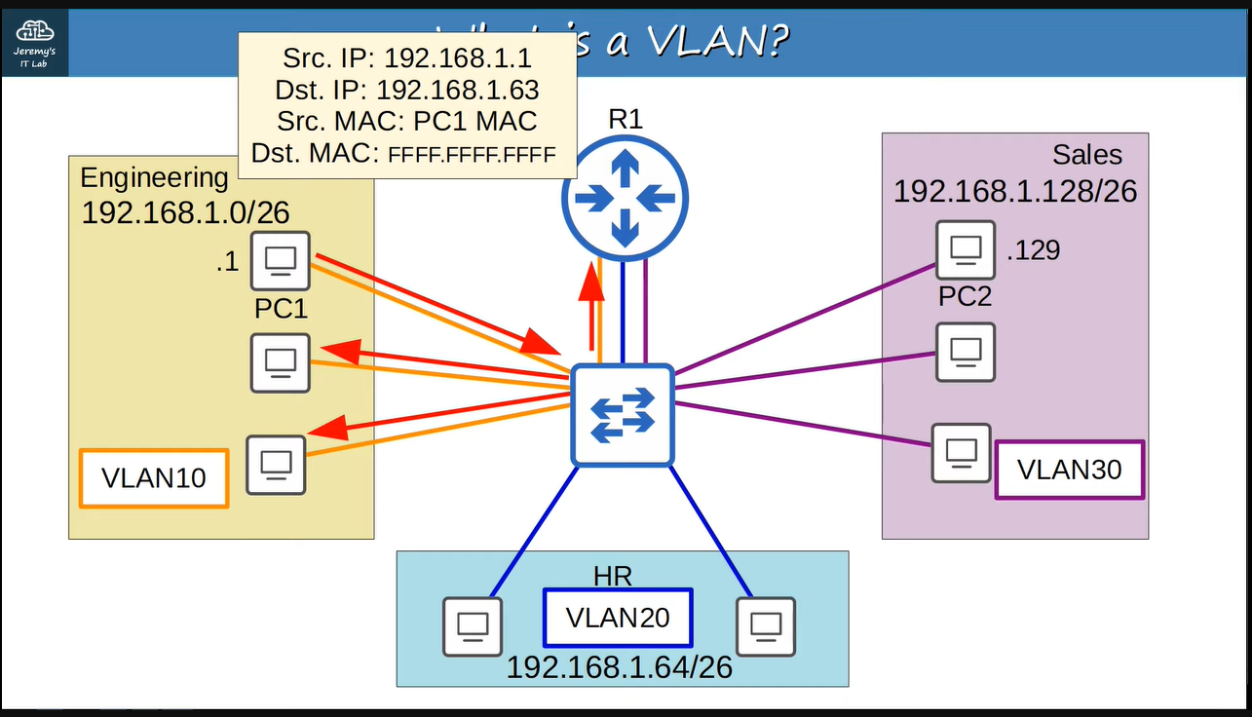

**If PC1 sends the frames to PC2 then it will be forwarded through the router ↓**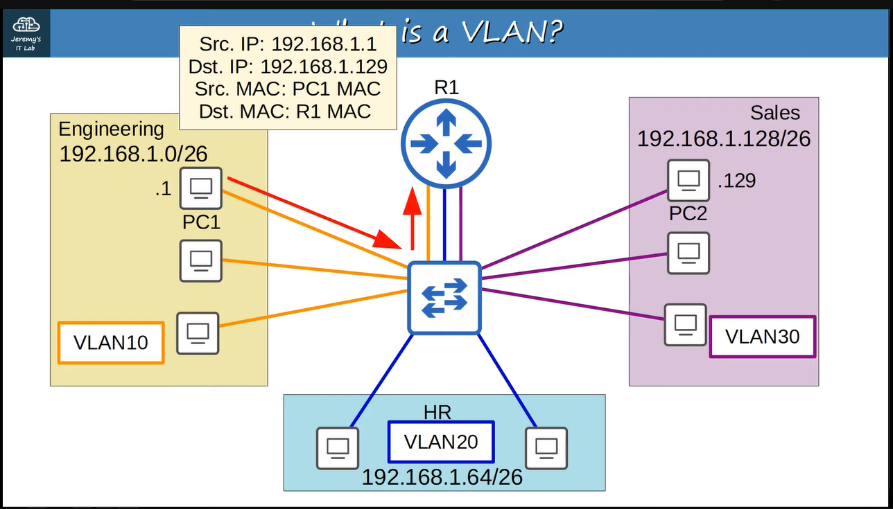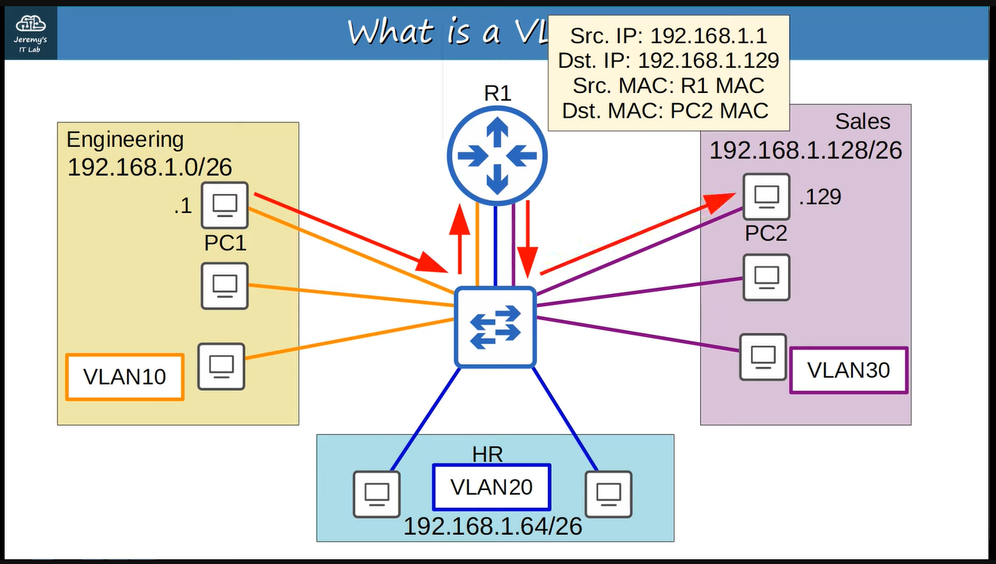

**We can say that the switch does not perform inter-VLAN routing, i.e., PC1 cannot send it to PC2 directly only with the help of switch, even if the PC1 & PC2 were in the same subnet.**

**Now we will see the configuration of VLAN according to this topology ↓**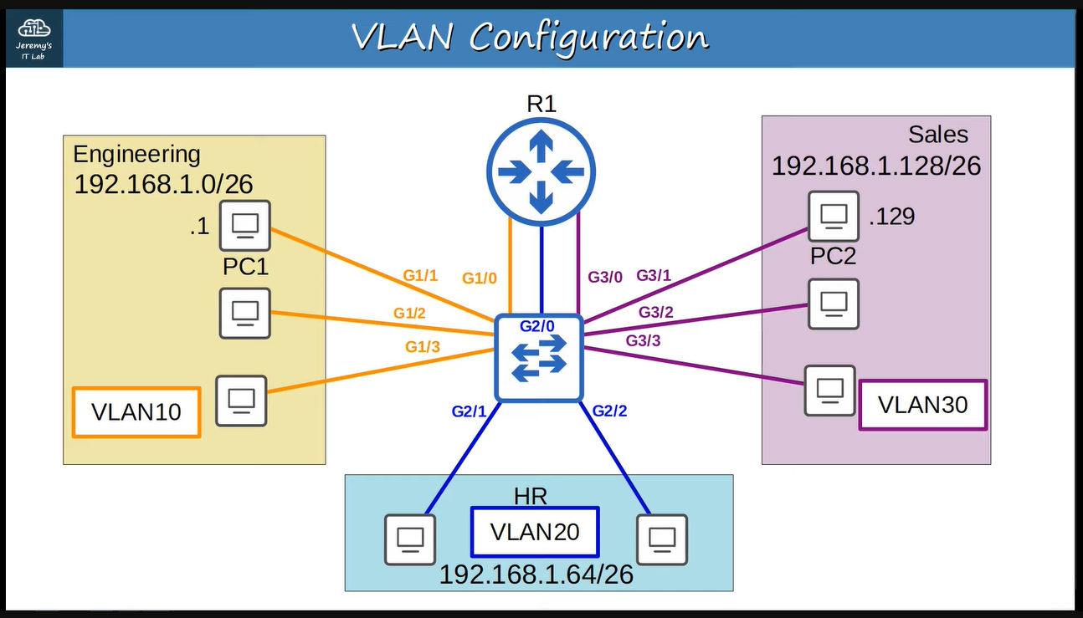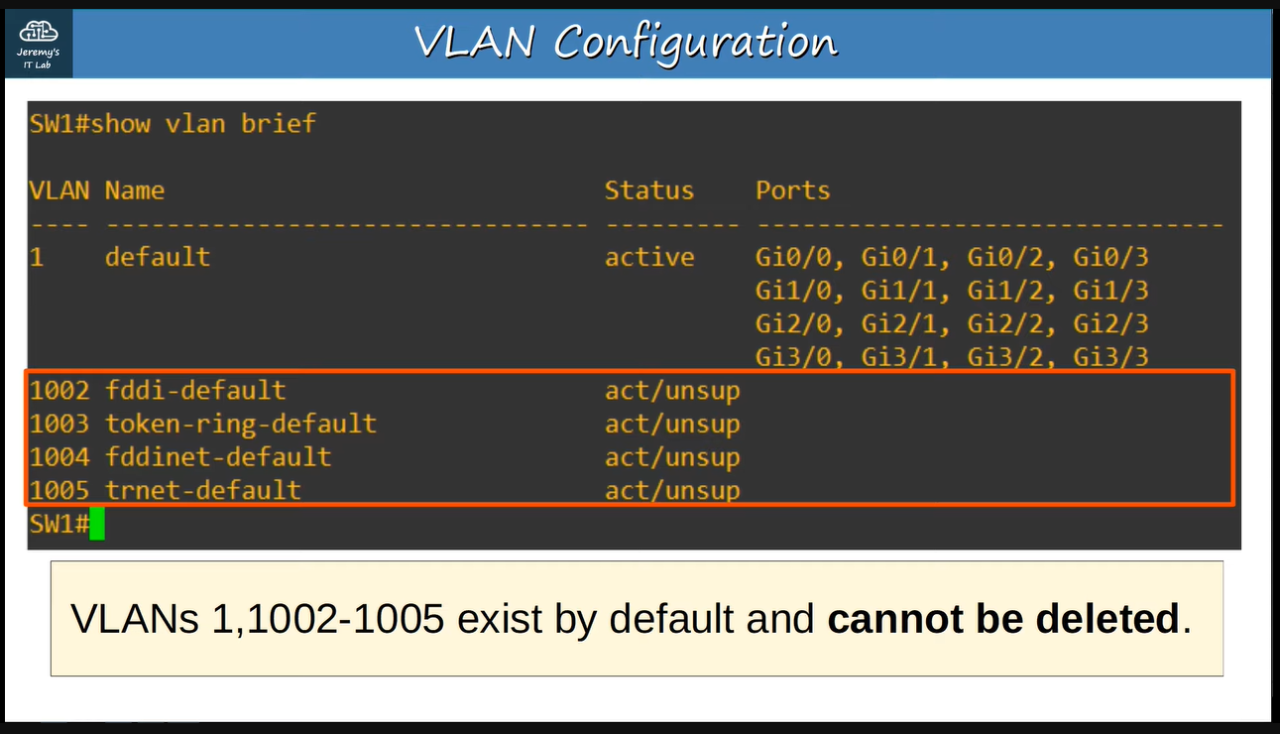

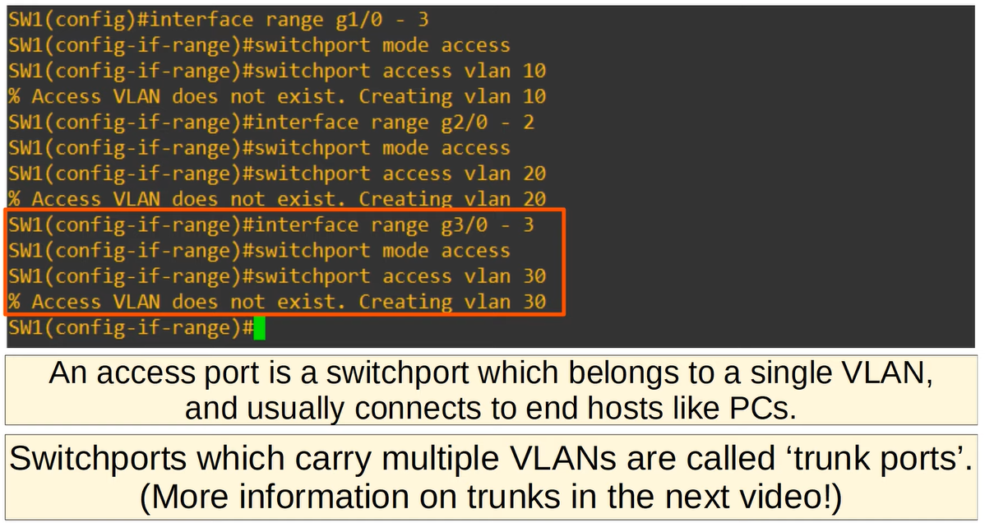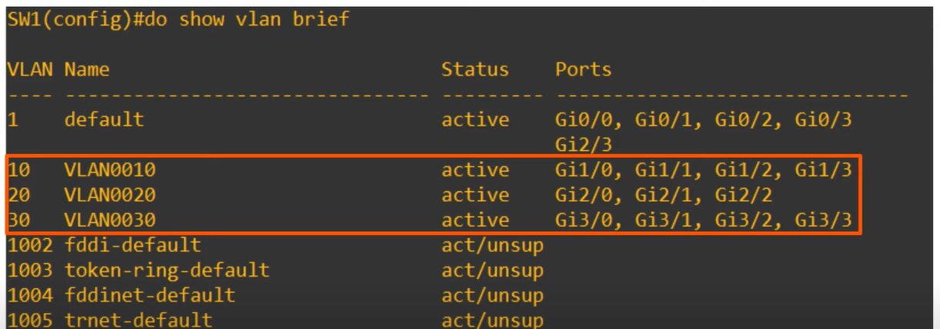

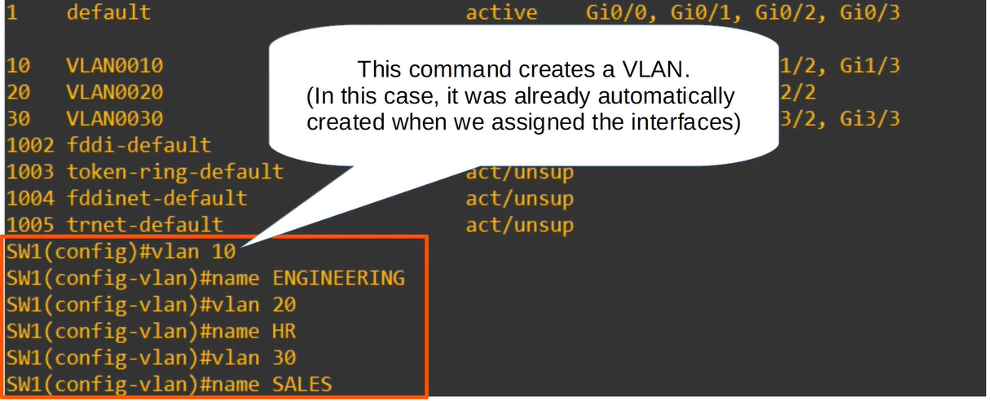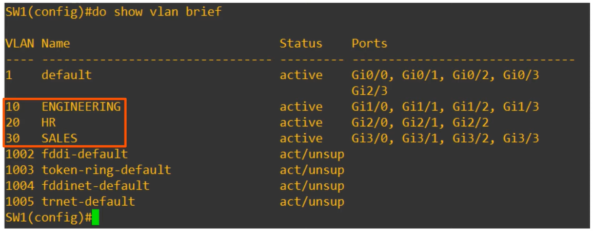

**If PC1 sends broadcast message then the switch will forward it to the VLAN10 only**

**and the router ↓**